;l

Foundations of Programming

Assignment No. : 4
- PROBLEM STATEMENT: Write a C Program to calculate the salary of an employee given his basic pay (taken as input from the user). Calculate gross salary of employee. Let HRA be 10 % of basic pay and TA be 5% of basic pay. Let employees pay professional tax as 2% of total salary. Calculate net salary payable after deductions.

OBJECTIVE:

- To understand the importance of flowchart for any programming model.
- To learn simple flowchart symbols and arrows to define relationships.
- To understand and develop visual representations of flow of data.

THEORY:
- Define Algorithm.
- What are the different characteristics of an algorithm.
PLATFORM: Linux

INPUT:

#include <stdio.h>

int main() {
int num;
float hra,ta,gross_sal,pro_tax,net_sal;

printf("ENTER YOUR BASIC PAY: ");
scanf("%d",&num);
hra=0.1*num;
ta=0.05*num;
gross_sal=num+hra+ta;
pro_tax=gross_sal*0.02;
net_sal=gross_sal-pro_tax;
printf("YOUR GROSS SALARY IS: %.2f\n", gross_sal);
printf("YOUR NET SALARY IS: %.2f\n", net_sal);

return 0;
}

OUTPUT:

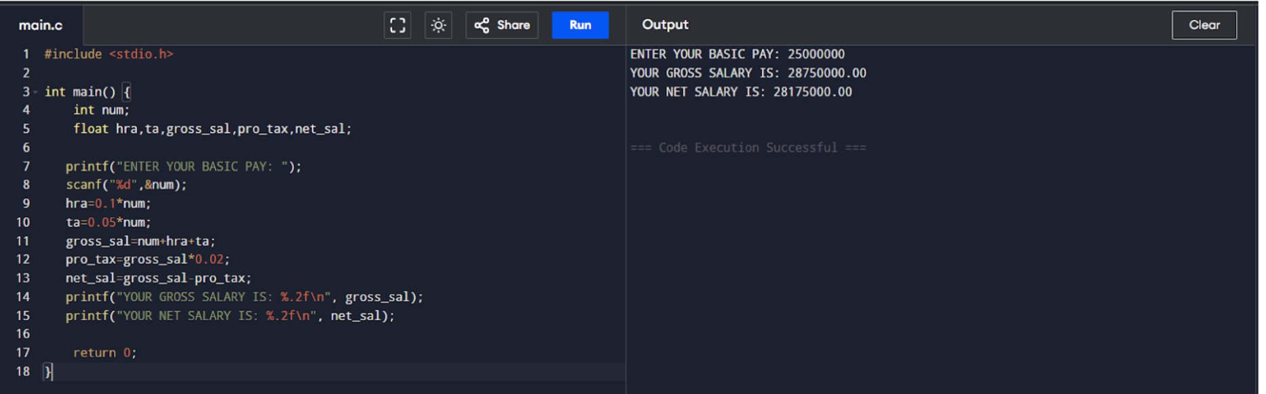
CONCLUSION: Thus, we have learned to write algorithms and to draw its representation in terms of flowchart.

FAQs:
- Describe various symbols and their use in flowchart.
- Difference between Algorithm and Flowchart.

